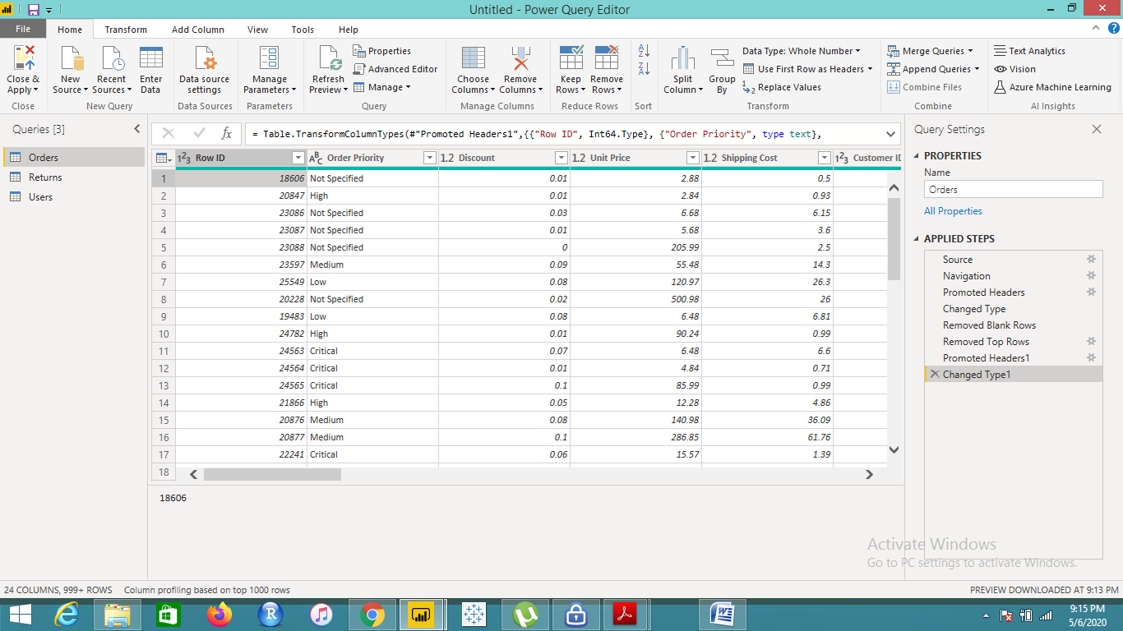

**Text Table of Customers, Product Category, Region in terms of Sales**

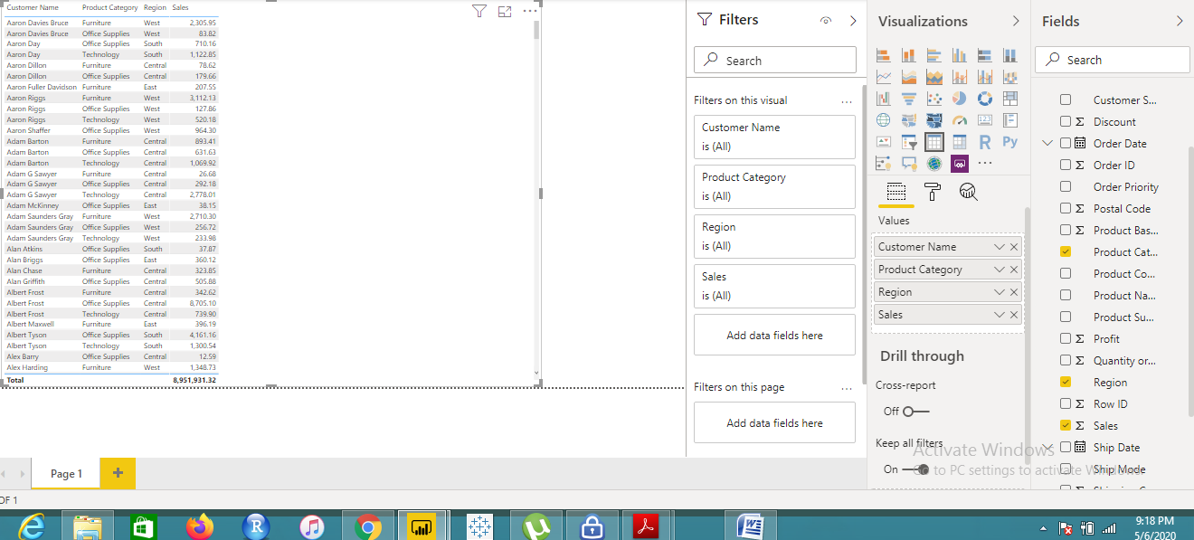

**Line and Clustered Column Chart showing the Sales and Discount as per the State or Province.**

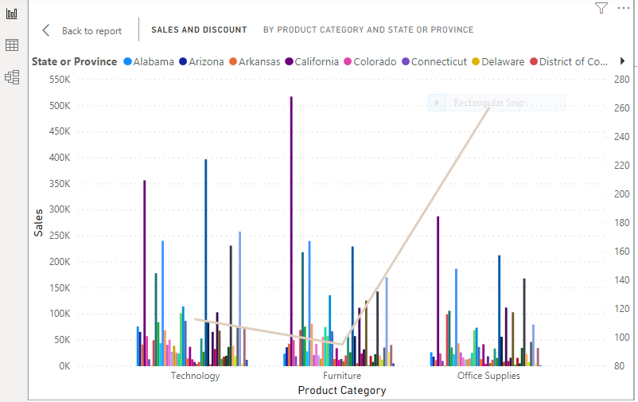

**New York** has the highest sales in terms of technology.

**Sales by Product Category**

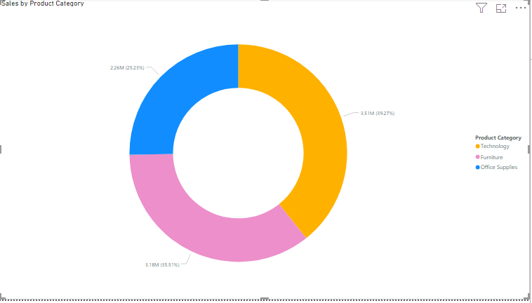

**Sales by Product Category (Central Region)**

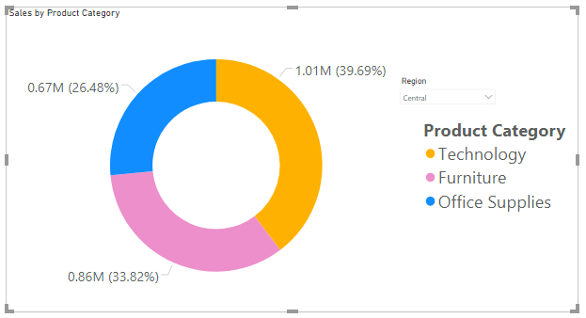

**Sales by Product Category (East Region)**

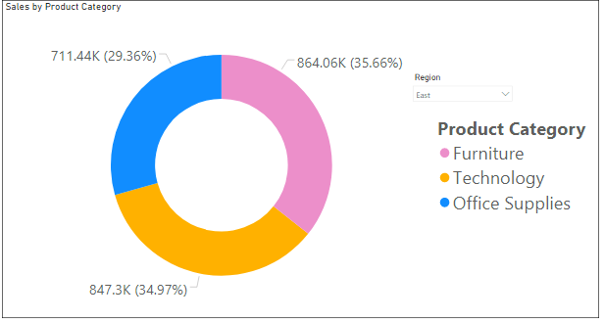

**Sales by Product Category (South Region)**

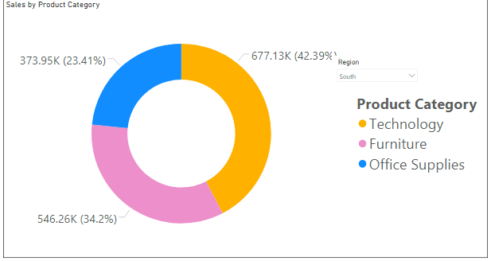

**Sales by Product Category (West Region)**

